- (a) An equation for the speed v of longitudinal waves in a thin rod of an elastic solid of
Young modulus E and density  is given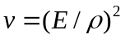. Show whether the equation is homogenous or not. [3]

- A student measured the volume of a polymer cylinder by finding its dimensions with a ruler. He recorded his reading as follows:

diameter of cylinder = (16 ± 1) mm
height of cylinder = (28 ± 1) mm

  - Find the percentage uncertainty of the volume of the cylinder.

percentage uncertainty = ………..…% [2]

  - Comment on the student’s choice of apparatus. How would you improve on his measurement?

…………………………………………………………………………………………………………...………………………………………………………… [2]

- A cyclist pedals downhill on a road, as shown in Fig. 2.1 , from rest at the top of the hill and reaches a horizontal section of the road at a speed of 20 ms⁻¹. The total mass of the cyclist and the bicycle is 70 kg.

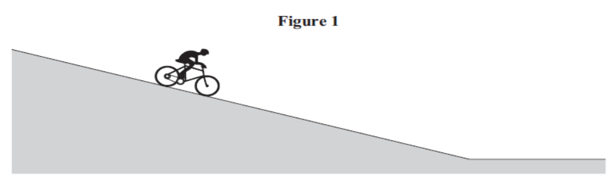
Fig. 2.1

(a) (i) Calculate the total kinetic energy of the cyclist and the bicycle on reaching the horizontal section of the road.

total kinetic energy = ………….…….J [2]

(ii) The height difference between the top of the hill and the horizontal section of the road is 10 m.
Calculate the loss of gravitational potential energy of the cyclist and the bicycle.

loss of gravitational potential energy = ……………..J [2]

(iii) The work done by the cyclist when pedaling downhill is 12 500 J. Account for the difference between the loss of gravitational potential energy and the gain of kinetic energy of the cyclist and the bicycle.

…...............................................................................................................................................…............................................................................................................................................................................................................................................................................................................................................................................................[3]

(b) The cyclist stops pedaling on reaching the horizontal section of the road and slows to a standstill 150 m further along this section of the road. Assume the deceleration is uniform.
(i) Calculate the time taken by the cyclist to travel this distance.

time = … …………s [2]

(ii) Calculate the average horizontal force on the cyclist and the cycle during this time.

force = …………………N [2]

3. Fig. 3.1 shows a clockwise crane that is used to lift a container of mass 22000 kg from a cargo ship onto the quayside. The container is lifted by four identical ‘lifting’ cables attached to the top corners of the container.
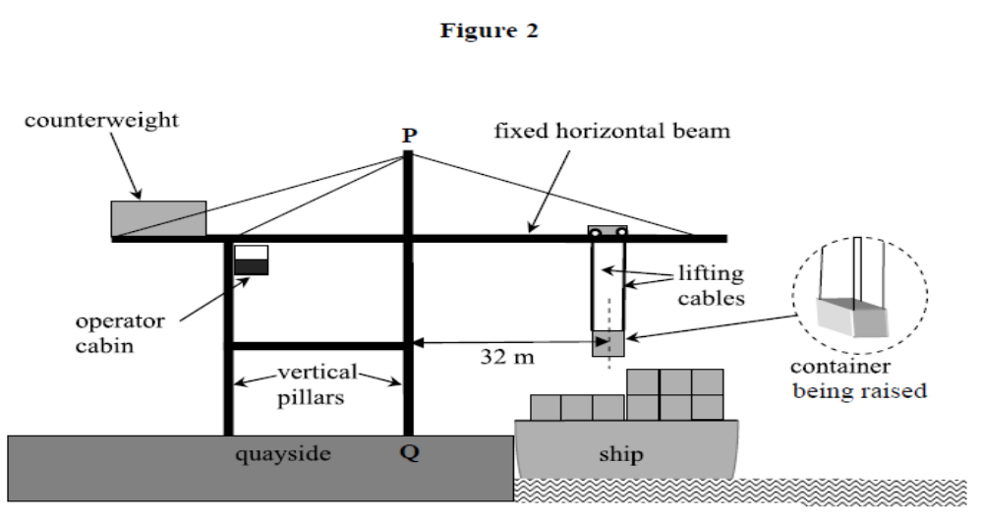
Fig. 3.1

(a) When the container is being raised, its centre of mass is at horizontal distance 32 m from the nearest vertical pillar PQ of the crane’s supporting frame.
(i) Assume the tension in each of the four lifting cables is the same. Calculate the tension in each cable when the container is lifted at constant velocity.

tension = ……………...….N [2]

(ii) Calculate the moment of the container’s weight about the point Q on the quayside, stating an appropriate unit.

moment = ………………….. [3]

(iii) Describe and explain one feature of the crane that prevents it from toppling over when it is lifting a container.

…………………………………………………………………………………….…..………………………………………………………………………………………..…………………………………………………………………………………… [2]

(b) Each cable has an area of cross-sectional of 3.8 × 10⁻⁴ m².
(i) Calculate the tensile stress in each cable, stating an appropriate unit.

stress = …………….……… [3]
(ii) Just before the container shown in Fig. 3.1 was raised from the ship, the length of each lifting cable was 25 m. Show that each cable extended by 17 mm when the container was raised from the ship. (Young modulus of steel = 2.1 × 10¹¹ Pa )
[3]

- Microwaves from a microwave transmitter are directed normally at a metal plate. A small probe that detects microwaves is connected to a suitable meter and then moved slowly along the line between the metal plates and the transmitter. As the probe moves along the line, the meter reading falls to zero every time the probe is moved through a distance of 15 mm.

  - Explain why the meter reading varies with the position of the probe.

…………………………………………………………………………………..…….…………………………………………………………………………………… [2]

  - Calculate the frequency of the microwaves.

frequency = ……...……..Hz [2]

  - How would the observations differ if frequency of microwave is doubled?

…………………………………………………………………………………..…….……………………………………………………………………………………………… [1]

5. Two horizontal metal plates P and Q are at a distance 0.62 cm apart. A charged particle of mass 5.1 × 10⁻¹⁵ kg is situated in a vacuum between the plates, as illustrated in Fig. 5.1. The potential difference between the plates is adjusted until the particle remains stationary.

0.62 cm
P
Q
charged particle
-300 V
Fig. 5.1

- State, with a reason whether the particle is positively or negatively charged.

…………………………………………………………………………………..………..………………………………………………………………………………… [2]

- The potential difference required for the particle to be stationary between the plates is found to be 300 V. Calculate
  - the electric field strength between the plates,

field strength = …………………..NC⁻¹ [2]

  - the charge on the particle.

charge = ……………………….. C [3]

- Suggest and explain what you can modify to keep a particle with greater mass stationary between the two plates.

…………………………………………………………………………………..…….
…………………………………………………………………………………..…….…………………………………………………………………………………… [2]

6. Fig. 6.1 shows an arrangement of resistors.
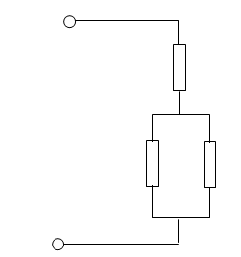 Fig. 6.1
A
25 Ω
400 Ω
400 Ω
B

(a) Calculate the total resistance between terminal A and B.

total resistance =………...……….Ω [2]

(b) A potential difference is applied between the two terminals A and B and the power dissipated in each of the 400 Ω resistors is 1.0 W.
(i) Calculate the potential difference across the 400 Ω resistors.

p.d. = ….. …….………… V [2]
(ii) Calculate the current through the 25 Ω resistor.

current = …………...…… A [2]
.
(iii) Calculate the potential difference applied to terminals A and B.

p.d.= …….…….……. V [2]
7. The radioactive decay of nuclei is both spontaneous and random.

(a) Explain what is meant by
(i) radioactive decay of a nucleus,

..........................................................................................................................................
..................................................................................................................................... [2]

(ii) spontaneous decay,

..........................................................................................................................................
..................................................................................................................................... [2]

(b) (i) Complete the nuclear equation for the -decay of a Americium -241 nucleus.

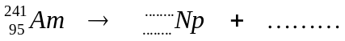 [2]

(ii) The unstable radioactive phosphorus isotopes have several modes of decay.
Phosphorus-32 decays by emission of a beta particle (an electron). Fig. 7.1 shows the position of Phosphorus-32 (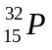) on a diagram in which nucleon number (mass number) A is plotted against proton number (atomic number) Z.
On Fig. 7.1, show this decay by labelling the position of the daughter product as D. [1] 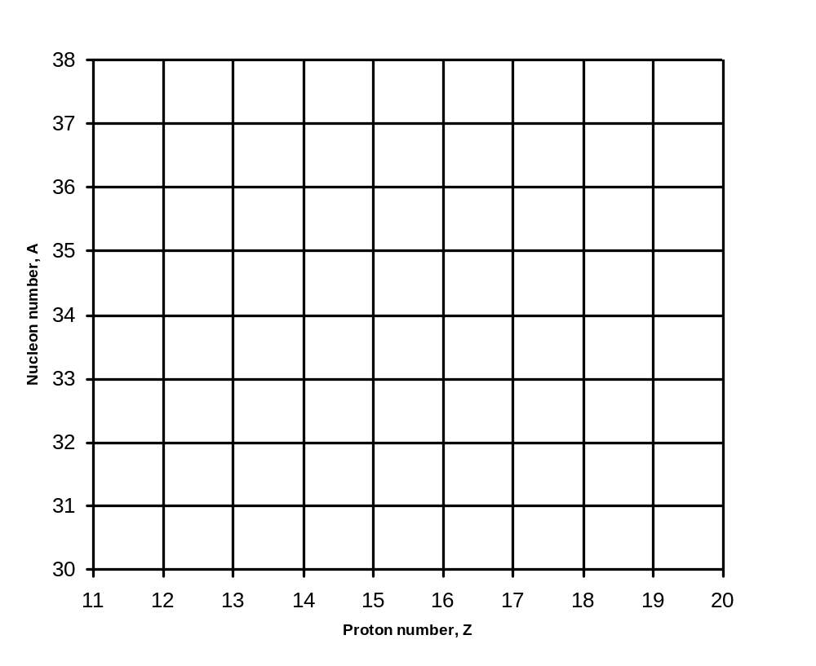
Fig. 7.1
P

